**CONTENT**

1.DATA READING AND PREPROCESSING

2. DATA VISUALIZATION

3. CLUSTERING

Jupyter notebook was installed and necessary libraries like panda , numpy etc were also installed. Each cell were run to see the result

The data set was downloaded from <https://archive.ics.uci.edu/ml/datasets/wine>

The attributes are:

1. Alcohol
2. Malic acid
3. Ash
4. Alcalinity of ash
5. Magnesium
6. Total phenols
7. Flavanoids
8. Nonflavanoid phenols
9. Proanthocyanins
10. Color intensity
11. Hue
12. OD280/OD315 of diluted wines
13. Proline

1.DATA READING AND PREPROCESSING

Removing the information about the types of wine for unsupervised learning. There were no object data type so there was no need to convert the attribute to integer. There were also no missing data in the data set.

2. DATA VISUALIZATION

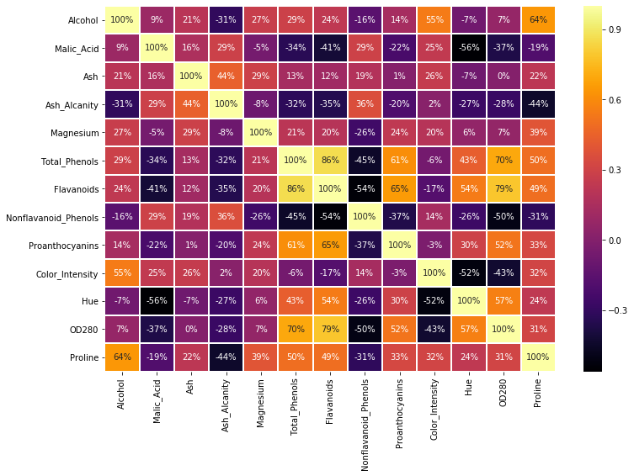

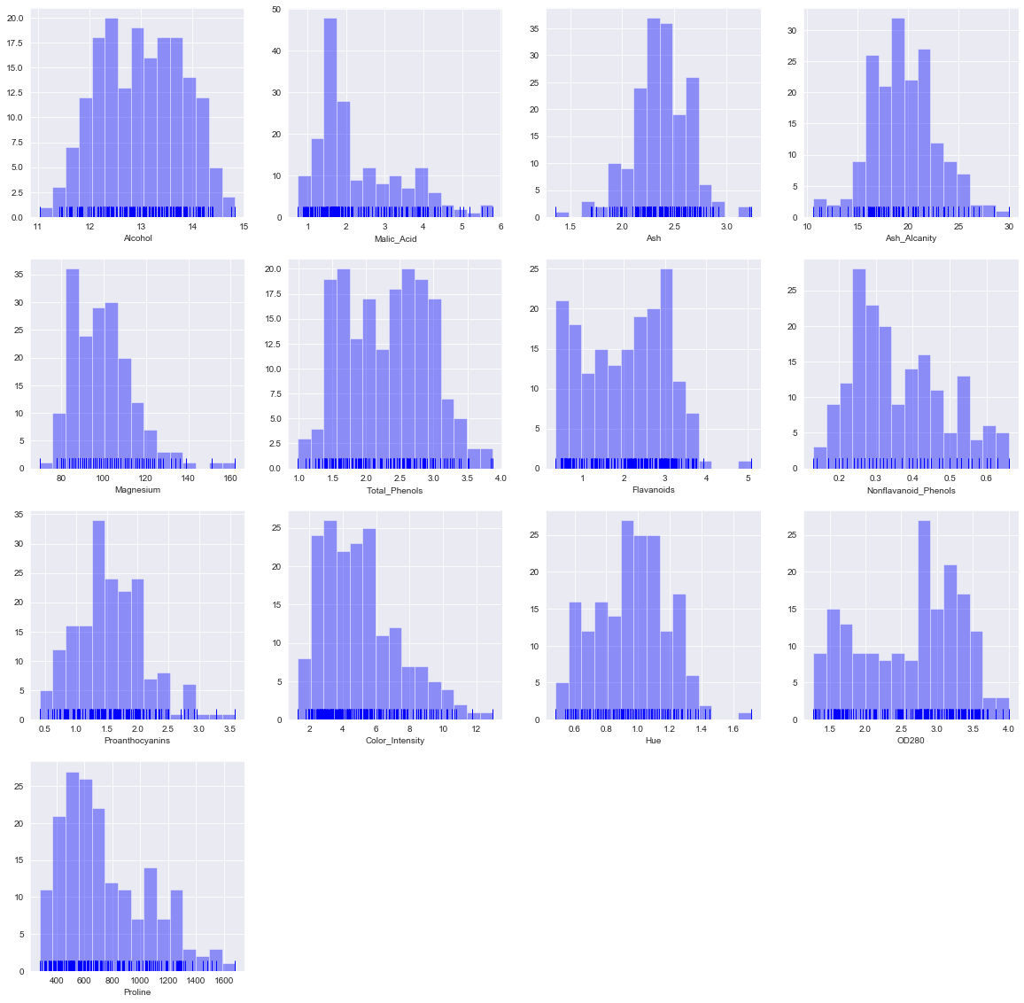

Linegraph of different attributes in the data set

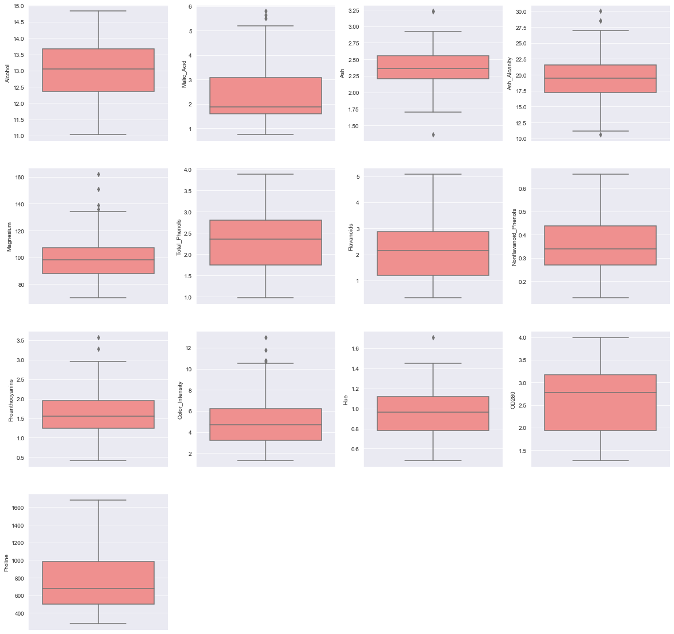

Box plot of different attributes.

K MEAN CLUSTERING

K AS 2

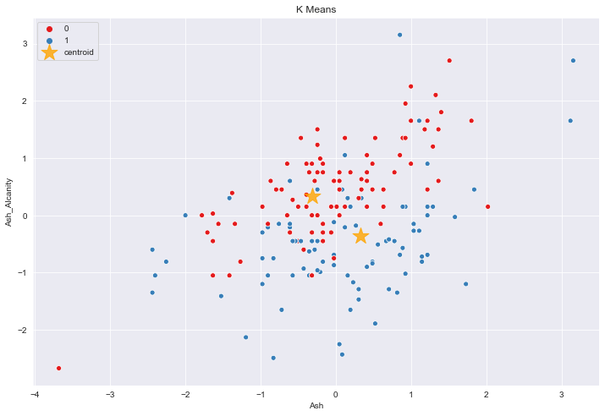

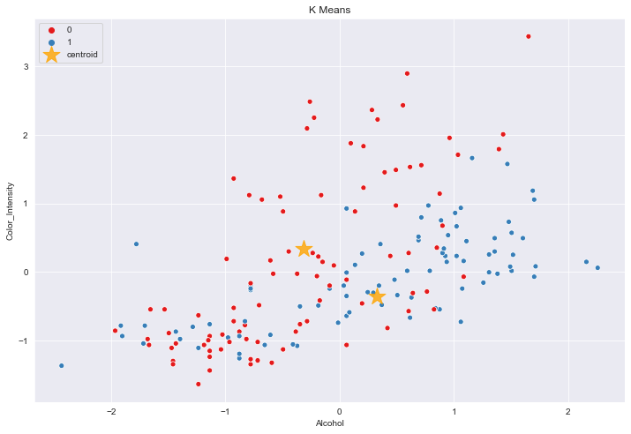

K as 3

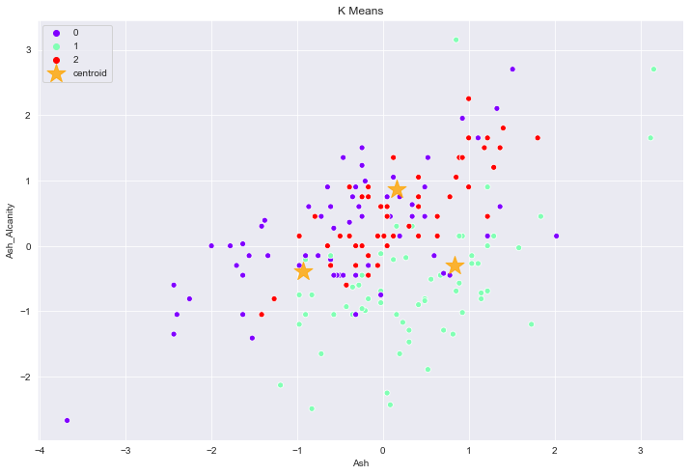

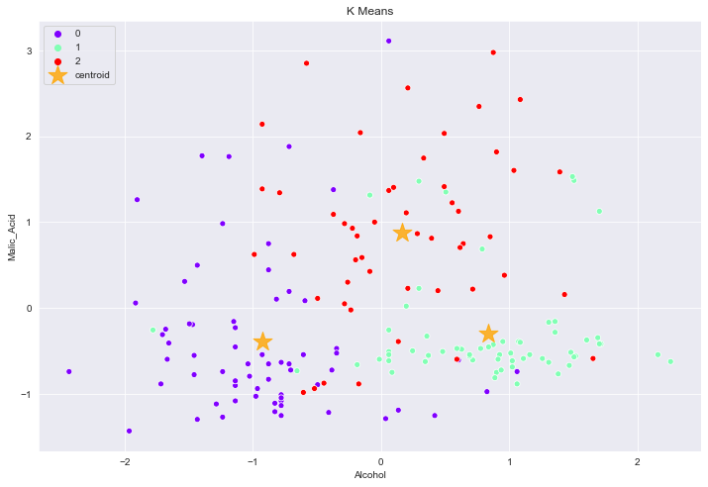

K as 5

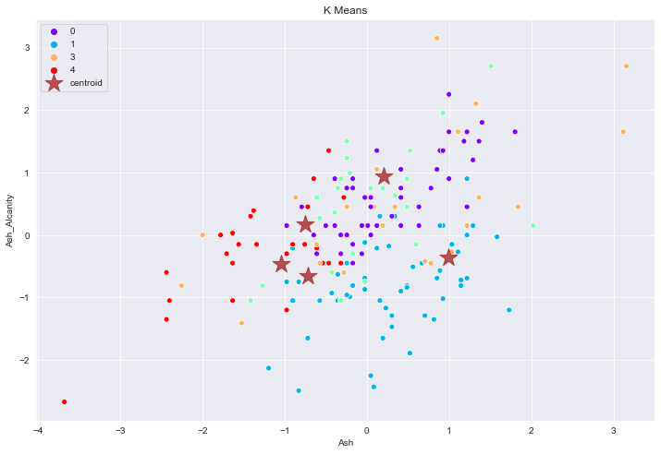

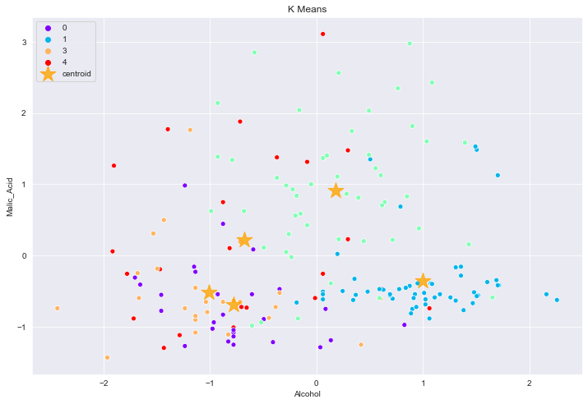

DB SCAN WITH EPS 0.5

